Belex Morning note

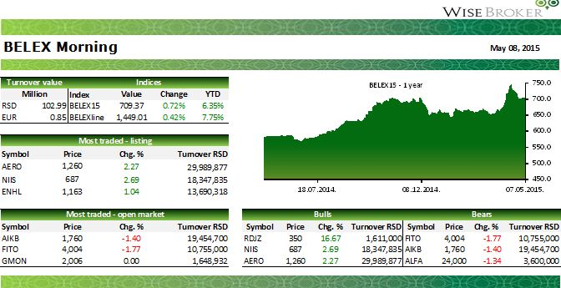

|  |  |  |  |  |  |  |  |  |
| --- | --- | --- | --- | --- | --- | --- | --- | --- |
|  | **Economy** | | | |  | | | |
|  |
|  | cid:image002.jpg@01D08968.C0826700 | | | | | | |  |
|  |  | | | | | | | |
|  | **PM: Serbia emerges from recession this year**  Serbian Prime Minister Aleksandar Vucic is certain that this year Serbia will emerge from reces­sion, and that in 2016 Serbia will be one of the most successful countries in the region. Vucic said in his address at the Reality Check conference organized by the Foreign Investors Council (FIC) that if the interest rates, which had to be paid in the previous period, were excluded, Serbia would have had a budget surplus after many years. “If we exclude the paying of interest rates in the first four months, budget surplus stands at RSD 32.4bn,” Vucic said. As for Serbia's economic growth, Vucic noted that he expects that it will go to zero percent at the end of the year from the initially forecasted minus one percent, and then minus 0.5%. “We will not be in recession, I am certain that we will emerge from it as early as in 2015, and that in 2016 Serbia will be one of the most successful countries in the region,” Vucic said. The prime minister underlined that the Serbi­an government will continue to implement the program with the IMF since that is good for our country.  Source: Tanjug | | | | | | | |
|  |
|  | cid:image003.jpg@01D08968.C0826700 |  | | | | | | |
|  |  | **Serbia sells RSD 2.79bn (EUR 23.1m) in 3-mo T-bills**  Serbia sold on Thursday RSD 2.79bn (EUR 23.1m) in three-month Treasury bills, equal to 92.92% of its offer, the finance ministry's treasury department said. The treasury department said in a statement it sold the T-bills at an annual yield of 5.63%, down from the 6.45% achieved at the previous three-month T-bills auction held on April 16th. The government paper will mature on Au­gust 6th, 2015.  Source: SeeNews | | | |  | |
|  |
|  |  | |
|  | cid:image004.jpg@01D08968.C0826700 |  |
|  | **Economy** | |  | | | | |
|  |  |
|  | cid:image005.jpg@01D08968.C0826700 | | | | | | |  |
|  |  | | | | | | | |
|  | **DNOS: Insurer Dunav Osiguranje’s consolidated net loss shrinks to RSD 3bn in 2014**  State-owned insurance company Dunav Osiguranje (DNOS) posted a consolidated net loss of slightly under RSD 3bn in 2014, an improvement on nearly RSD 4.84bn the year before, accord­ing to the company’s financial report on the Belgrade Stock Exchange (BSE) website. Dunav’s consolidated operating revenues stood at RSD 18bn, down from RSD 19.2bn in 2013. Dunav has seven subsidiaries, two of which are in Banja Luka in the Bosnian Serb entity Republika Srpska, and the rest in Belgrade, including reinsurer Dunav-Re. Dejan Hadzic, an adviser at the Finance Ministry, said recently that the privatization of Dunav Osiguranje should begin by the end of this year with the selection of a privatization adviser, according to earlier reports.  Source: Executive Newsletter | | | | | | | |
|  |
|  | **TIGR: Tigar reported consolidated net loss of RSD 1.3bn, for FY 2014, up 42% y/y**  Pirot-based rubber applications producer, Tigar (TIGR), reported RSD 1.3bn in its FY 2014 consoli­dated net loss, up 42% y/y on lower sales and higher financial loss. The company’s sales came in at RSD 1.93bn, down 13% y/y. Export provided 64% of revenues. Operating loss has been re­duced from RSD 437.2m in 2013 to current RSD 246.3m. The company’s financial restructuring has been approved, by major creditors, several weeks ago but we still see no material improve­ment. Accumulated loss already exceeded size of the company’s equity, while total debt remains high.  Source: Belex, Wisebroker | | | | | | | |
|  |
|  | cid:image006.jpg@01D08968.C0826700 | | | | | | | |
|  |  | | | | | | | |
|  | cid:image007.jpg@01D08968.C0826700 |  | | | | | | |
|  | Contact info: Vaso Dulovic broker, tel: 011 33 30 506, email: [vaso.dulovic@wisebroker.rs](mailto:vaso.dulovic@wisebroker.rs)  BDD WISE Broker, Takovska 23-25,  Belgrade, Serbia **If you wish no longer to receive this report, please return as with such request.** | | | |  | | |
|  |  |